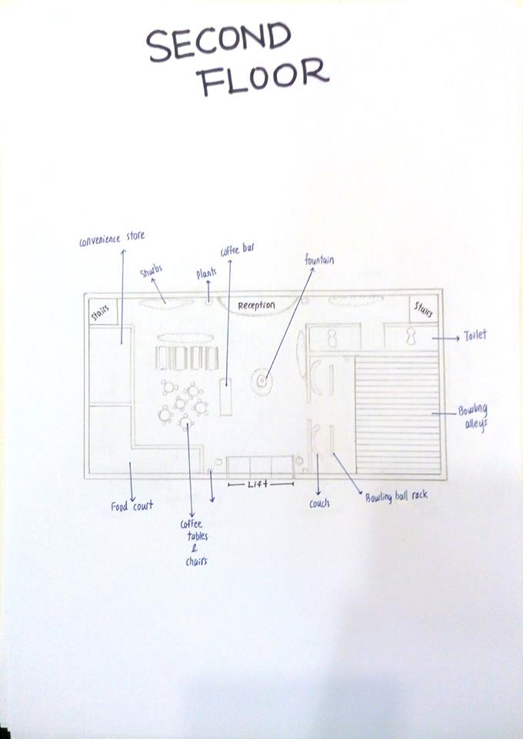
CONVENIENCE STORE

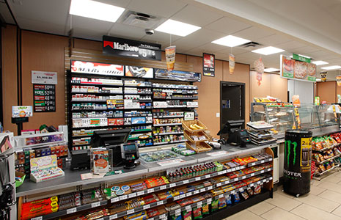

A convenience store, c-store, small grocery store, is a small store that stocks a range of everyday items such as groceries, snack foods, candy, toiletries, soft drinks, tobacco products, and newspapers. Such stores may also offer money order and wire transfer services. In some jurisdictions, corner stores are licensed to sell alcohol, typically beer and wine. They differ from general stores and village shops in that they are not in a rural location and are used as a convenient supplement to larger stores. In some countries, convenience stores have long shopping hours, some being open 24 hours.
Convenience stores usually charge significantly higher prices than conventional grocery stores or supermarkets, as convenience stores order smaller quantities of inventory at higher per-unit prices from wholesalers. However convenience stores make up for this with the convenience by having longer opening hours, serving more locations, and having shorter cashier lines.

FOOD COURT

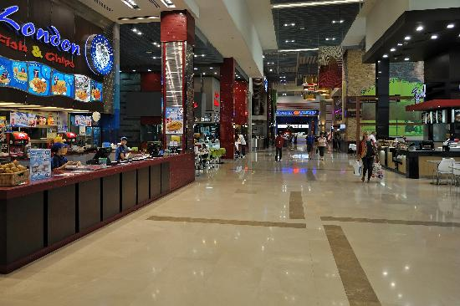

Food courts consist of a number of vendors at food stalls or service counters. Meals are ordered at one of the vendors and then carried to a common dining area. The food may also be ordered as takeout for consumption at another location, such as a home, or workplace. In this case, it may be packaged in foam food containers, though one common food tray used by all the stalls might also be utilitzed to allow the food to be carried to the table. Food courts may also have shops which sell prepared meals for consumers to take home and reheat, making the food court a daily stop for some.
COFFEE BAR


A coffee bar is an establishment similar to acoffee house or a coffee shop. However, coffee bars tend to be set up more like a bar, offering quick coffee drinks (particularly espresso shots) that can be drunk while standing or while seated on a bar stool or similar chair.
Many coffee bars outside of Italy have contemporary, European-inspired decor. However, the styles and numbers of chairs is often very different, reflecting a major cultural difference on how and when coffee is consumed.
In Italy, most drinks are quickly consumed at the bar, though it is sometimes possible to order and drink a drink while seated indoors or outdoors (though this may require a surcharge). Outside of Italy, coffee bars almost always offer cozy seats and drinks "to go," and consumers tend to either buy a drink to consume elsewhere or linger over a drink while using WiFi (which is often free of charge), chatting and relaxing.

BOWLING ALLEYS

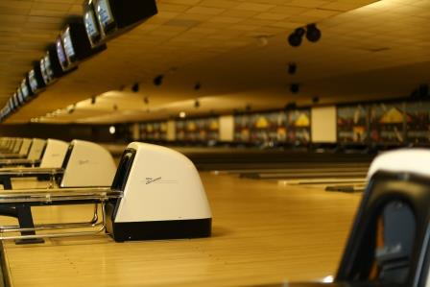

Bowling refers to a series of sports or leisure activities in which a player rolls or throws a bowling ball towards a target. In pin bowling variations, the target is usually to knock over pins at the end of a lane. In target variations, the aim is usually to get the ball as close to a mark as possible. The pin version of bowling is often played on a flat wooden or other synthetic surface, while in target bowling, the surface may be grass, gravel or a synthetic surface. The most common types of pin bowling include ten-pin, nine-pin, candlepin, duckpin and five-pin bowling, while in target bowling, bowls, bocce, carpet bowls,pétanque and boules, both indoor and outdoor varieties, are popular.
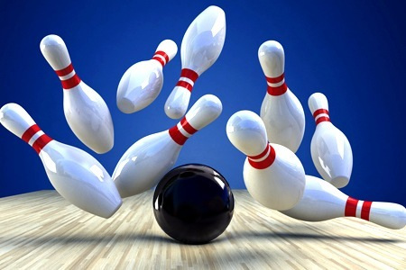
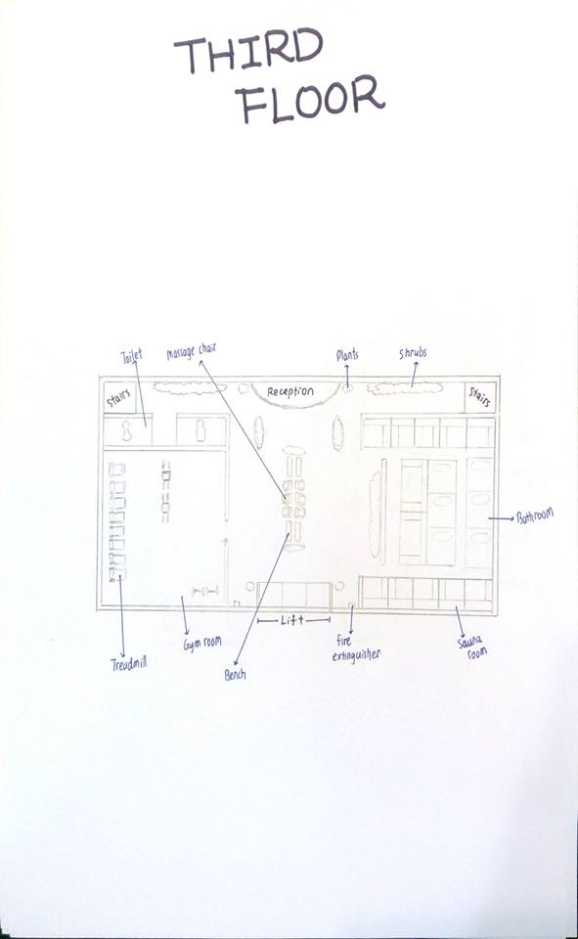

SAUNA

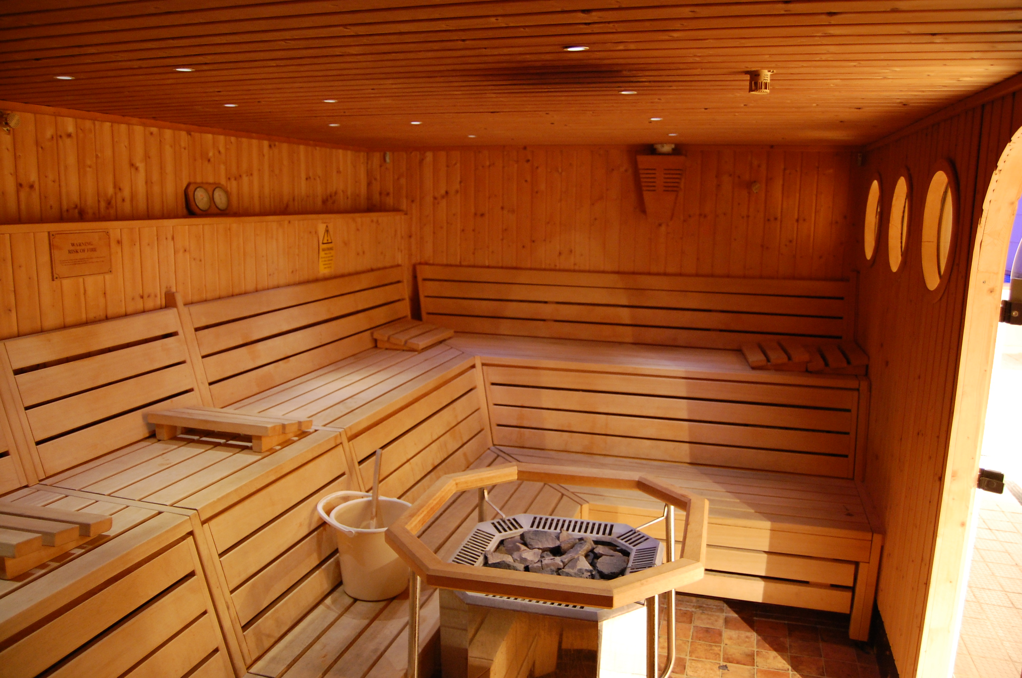

Sauna can take 30 minutes to heat up when first started. Some users prefer taking a warm shower before hand to speed up perspiration in the sauna. When in the sauna users often sit on a towel for hygiene and put a towel over the head if the face feels too hot but the body feels comfortable. In Russia, a felt "banyahat" may be worn to shield the head from the heat; this allows the wearer to increase the heat on the rest of the body.
Most adjustment of temperature in a sauna comes from :
- amount of water thrown on the heater, this increases humidity, so that sauna bathers perspire more copiously.
- length of stay in the sauna
- positioning when in the sauna
Heating caused by direct radiation will be greatest closest to the stove. Heating from the air will be lower on the lower benches as the heat rises.
GYM (FITNESS)
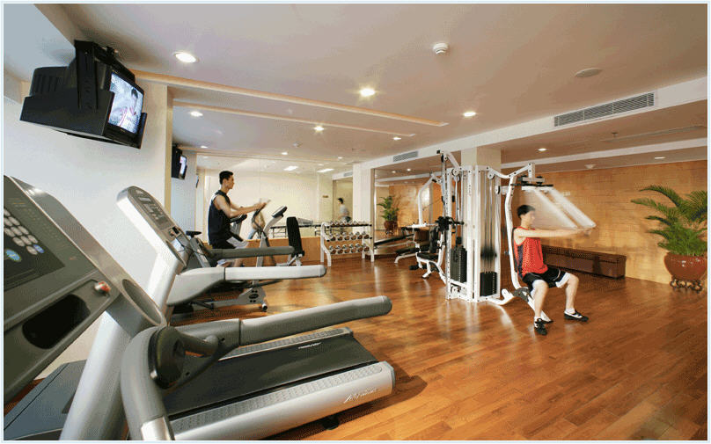
Gymnasia apparatus such as bar-bells, parallel bars, jumping board, running path, tennis-balls, cricket field, fencing gallery, and so forth are used as exercises. In safe weather, outdoor locations are the most conductive to health. Gyms were popular in ancient Greece.
The gyms had halls and colonnades with statues and pictures. These gymnasia also had teachers of wisdom and philosophy. Community gymnastic events were done as part of the celebrations during various village festivals. In ancient Greece there was a phrase of contempt, "He can neither swim nor write." After a while, however, Olympic athletes began training in buildings just for them. Community sports never became as popular among ancient Romans as it had among the ancient Greeks. Gyms were used more as a preparation for military service or spectator sports.
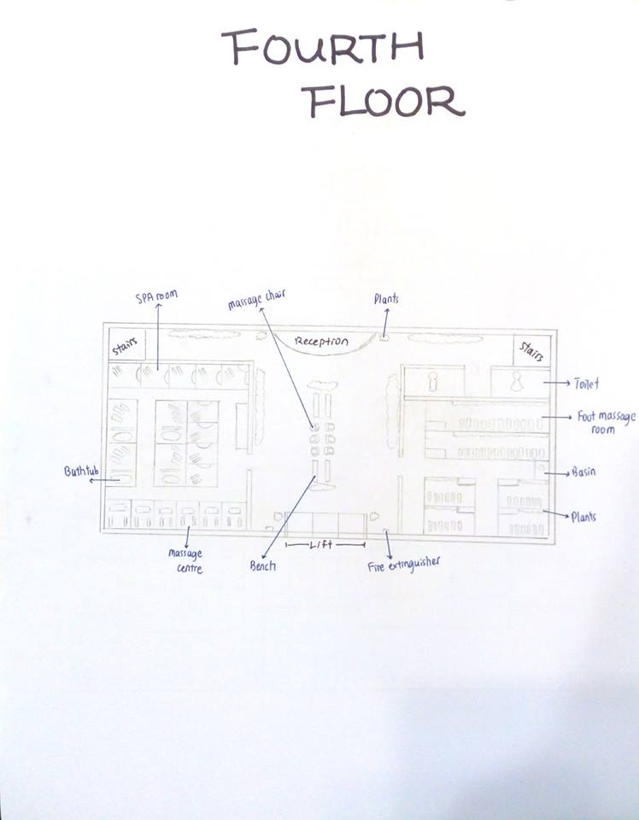
FOOT MASSAGE
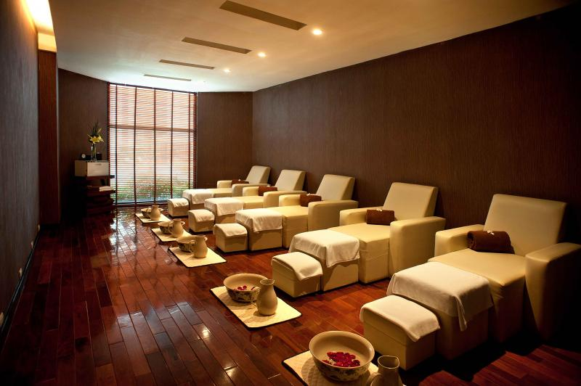

Combine a regular foot massage with reflexology to promote psychological as well as physical health. Reflexology is an ancient healing practice based on the principle that there are reflex points on the feet that correspond to the body’s different organs and glands.
These points are located on the soles, ankles, toes and upper part of the foot. In reflexology, pressure is applied to special areas on the feet with specific thumb, finger or hand techniques.Stimulating and applying pressure to these reflexes on the feet is definitely pleasurable, but at the same time it helps promote good health.
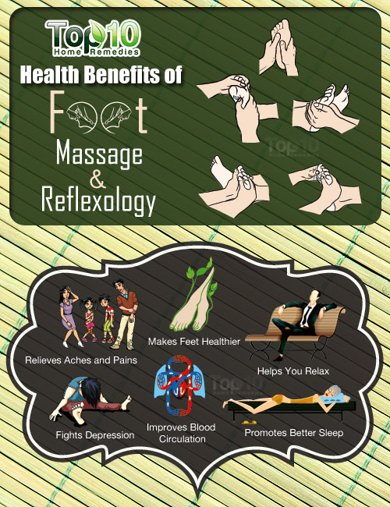
SPA
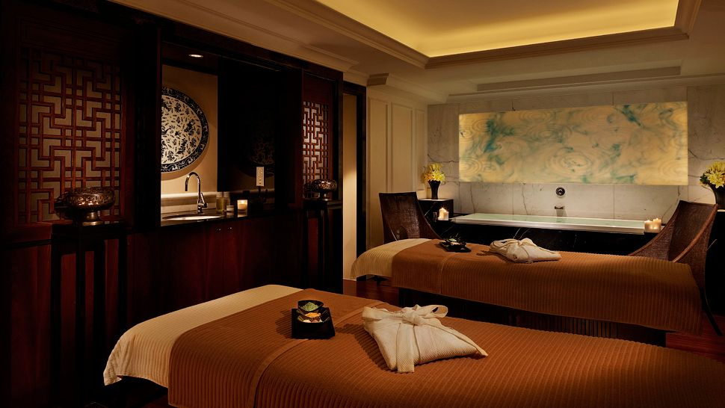
A spa is a location where mineral-rich spring water (and sometimes sea
water) is used to give medicinal baths. Spa towns or spa resorts (including hot springs resorts) typically offer various health treatments, which are also known as balneotherapy.
A day spa can be a blessing, a place that helps you indulge in some much-needed 'me' time, to switch off and relax, recharge, reflect, detox and beautify. Modern-day spas cater to a range of health-promoting experiences. The healing powers of touch therapy have been expounded on since ancient times. Spas and touch therapies are thus intrinsically connected. The nurturing touch of a skilled therapist's hands on one's body has benefits that go beyond the realm of the physical.


Professions Involved
- Architect
- Contractor
- Construction Manager
- Solar Thermal Installer
- Quantity Surveyor
- Civil and Structural Engineering
- Supplier
- Mechanical Engineering
- Electrical Engineering

ARCHITECT
An architect is someone who loves to design, and is specifically trained and licensed to work on the planning and design of buildings. The facets of an architect's role are as varied and fascinating as their work; these are professionals who lead the process of creating functional spaces, from concept and design to a full realization of those designs.
Architecture is an art that works hand in hand with science to design places where people can live, eat, work and play. As a leader of various projects, from something as small as an addition to someone's home, to something as large as a hospital, college campus, or an entire neighbourhood, the role of an architect is to bring together the creative ideas and visions of the client and keep in mind the needs of those that will be using the new space.
In the design role, an architect is hired by a client to produce detailed designs of a concept or idea that the client wants to bring to reality. As well as needing creative design ideas, this part of the role involves a great deal of technical knowledge and responsibility. There is a need to comply with building and safety regulations, local planning regulations and restrictions. Depending on the project there may be laws surrounding the preservation of the local environment or any historic parts of a building. Regular client meetings are important to establish requirements and discuss detailed design proposals. Also important is heading up the team of professionals who will work on this stage of the project including engineers, designers and financiers.

During the documentation phase, the responsibilities are to capture the design on paper, producing detailed drawings and using technology such as CAD to test the feasibility of the design. This stage can involve continual revision and redrawing to incorporate changes based on the client's requirements, budget and regulations. Once the design documents are complete, there are then a second set of documents that need to be produced.

What is the workplace of an Architect like?
The variety of roles means that there are also a variety of workplaces. Most of the design work will be done from an office, but there will also be visits to clients' offices, meetings with planning offices and local government, and of course site visits. Depending on whether they are freelance or employed by a company, an architect may work from their own office, sometimes from home, or from a number of company offices. The role can involve travel and international conferences, placements or meetings.

CONTRACTOR
Contractor is someone who directly employs or engages construction workers or manages construction. In this project, contractor need to appoint a designer or a subcontractor to ensure the designer or contractor has the skills, knowledge and experience and, where relevant, organisational capability to carry out the work for which they are being appointed.
A contractor also need to overseeing the whole project and make sure everyone did their job well, and the work can be done before the due date. Beside of employing the profession and worker, contractor need to manage and organize all aspects of a building site.
The building contractor is also responsible for obtaining materials for the project. As a contractor, they need to search for suppliers for different materials that are needed in the project and compare the quality and price of it, try to lower the budget and obtain good quality of materials.
Another responsibility of contractor is to acquire all necessary licenses and permits from relevant entities so that the building project can begin. These range anywhere from building licenses to zoning permits and there are many regulations that relate to these documents which each building contractor must follow in order to engage in construction.

CONSTRUCTION MANAGER
Construction managers, also called general contractors or project managers, typically do the following:
- Prepare and negotiate cost estimates, budgets, and work timetables
- Select appropriate construction methods and strategies
- Interpret and explain contracts and technical information to workers and other professionals
- Report on work progress and budget matters to clients
- Collaborate with architects, engineers, and other construction and building specialists
- Instruct and supervise construction personnel and activities onsite
- Respond to work delays and other problems and emergencies
- Select, hire, and instruct laborers and subcontractors
- Comply with legal requirements, building and safety codes, and other regulations
Construction managers coordinate and supervise a wide variety of projects, including the building of all types of residential, commercial, and industrial structures, roads, bridges, power plants, schools, and hospitals. They oversee specialized contractors and other personnel. They schedule and coordinate all design and construction processes to ensure a productive and safe work environment. They also make sure jobs are completed on time and on budget with the right amount of tools, equipment, and materials. Many managers also are responsible for obtaining necessary permits and licenses. They are often responsible for multiple projects at a time.
SOLAR THERMAL INSTALLER
A solar thermal installer is someone who installs and maintains solar energy systems that are designed for running solar-powered hot water for residential, commercial, and even industrial use. These systems are used in swimming pools, heating and cooling, water power generators, and domestic water heater devices.
Solar thermal installers plan and install the tanks, pipes and other components of hot water systems. They also plan and install the solar panels in the correct areas so as to gain the most sun power possible for the residence or building. They also must perform routine maintenance and repair on all of the components of the systems. They use different tools to make sure that the solar panels are functioning correctly and absorbing the sun power that they should. Through the use of smart phones and laptops, they analyze the solar site shade to be sure that the panels are working in an optimized manner.
With so many different duties that may be possible with this type of work, it can vary greatly from company to company and even in different countries and states. Some installers deal with all aspects of the install, maintenance, and repair. Some companies have electricians and plumbers that deal with those particular aspects of the job, and allow the solar thermal installer to be more focused on the solar panel programs and equipment.
QUANTITY SURVEYOR
A quantity surveyor (QS) is a professional working within the construction industry concerned with construction costs and contracts.
Services provided by a quantity surveyor may include:
- Cost planning and commercial management throughout the entire life cycle of the project from inception to post-completion
- Value engineering
- Risk management and calculation
- Procurement advice and assistance during the tendering procedures
- Tender analysis and agreement of the contract sum
- Commercial management and contract administration
- Assistance in dispute resolution
- Asset capitalisation
- Interim valuations and payment assessment
- Cost management process
- Assessing the additional costs of design variations
- Production of Company PQQ documentation in line with company policies.

Civil and Structural Engineer
Civil and Structural Engineer (C&S) is a group of expect who are designing and supervising large construction projects, including roads, buildings, airports, tunnels, dams, bridges, and systems for water supply and sewage treatment. They also trained to ensure the safety of certain building in a project. C&S need to produce with professional drawing, idea and reports and make calculation about the safety of the building. The structural engineer need to calculate the loads and stresses of a building to ensure it is strong enough to withstand the weight in a building.
Before the construction work start C&S need to go to the site to investigate about the hardness and quality of the land and ground and identify either it is suitable for the upcoming project.
Civil engineers work at the highest level of design and plan large infrastructure projects, such as airports and roadways, which requires solving complex problems. Civil engineers must determine the feasibility of plans, especially regarding financial costs and safety concerns. Urban and regional planners often look to civil engineers for advice on these issues. Civil engineers are ultimately responsible for the infrastructure project’s design and implementation. Therefore, they must be able to lead surveyors, construction managers, civil engineering technicians, and others to implement the plan.

SUPPLIER
Supplier is someone who provide goods and materials to a certain project. Supplier need to modify, package and supply the material to the site when it receive order.
Supplier can be a manufactured factory or someone who sell the materials. Some of the big supplier become a subcontractor and help the contractor to hire profession and install certain material into the building.
Supplier also need to provide with transportation of materials to the site and ensure the quality of material is excellent when it arrived at the site. A delivery timetable need to be fix to ensure the stores have enough stock.
Supplier need to come to a duel either will the architect, contractor or the QS about the price and the quantity of the material. Some of the supplier even provide services to modify the material such as curving the flat glass into sharp and additional charges will be calculated.
Supplier need to arrange the payment of materials from the contractor and make calculation about the bills of material that sent to the construction site.

MECHANICAL ENGINEERING

Mechanical engineers typically do the following:
- Analyze problems to see how a mechanical device might help solve the problem
- Design or redesign mechanical devices, creating blueprints so the device can be built
- Develop a prototype of the device and test the prototype
- Analyze the test results and change the design as needed
- Oversee the manufacturing process
Mechanical engineers use many types of tools, engines, and machines. Examples include the following:
- Power-producing machines such as electric generators, internal combustion engines, and steam and gas turbines
- Power-using machines, such as refrigeration and air-conditioning
- Industrial production equipment, including robots used in manufacturing
- Other machines inside buildings, such as elevators and escalators
- Machine tools and tools for other engineers
- Material-handling systems, such as conveyor systems and automated transfer stations
Like other engineers, mechanical engineers use computers extensively. Computers help mechanical engineers to produce and analyze designs, simulate and test how a machine is likely to work, generate specifications for parts, monitor the quality of products, and control manufacturing and production.
ELECTRICAL ENGINEERING
An Electrical Engineer is a specialized type of Engineer. Also known as: Electrical Project Manager Engineer, Electrical Project Engineer.
An electrical engineer is someone who designs and develops new electrical equipment, solves problems and tests equipment. They work with all kinds of electronic devices, from the smallest pocket devices to large supercomputers.
Electrical engineering deals with electricity, electro-magnetism and electronics. It also covers power, control systems, telecommunications and signal processing. These engineers are usually concerned with large-scale electrical systems such as motor control and power transmission, as well as utilizing electricity to transmit energy. Electrical engineers may work on a diverse range of technologies, from the design of household appliances, lighting and wiring of buildings, telecommunication systems, electrical power stations and satellite communications. They may plan their designs using computer-aided software or they may also sketch ideas by hand.
Electrical engineers usually work in a lab, an office, a mine or in industrial plants. An electrical engineer usually can pursue a technical career in any industry. They usually supervise computer programmers, electricians, scientists and other engineers. A typical work week is composed of 40 hours although there might be some overtime to meet deadlines.
Costing
No | Item | Unit | Quantity | Amount(RM)
1. | Cement | M2 | 500 | 12,500.00
2. | Brick | M2 | 570 | 14,250.00
3. | Roof | M2 | 2000 | 32,000.00
4. | Lamp | No. | 450 | 7,200.00
5. | Locker | No. | 30 | 3,600.00
6. | Dustbin | No. | 30 | 1,500.00
7. | Toilet bowl | No. | 14 | 1,400.00
8. | Sliding door | No. | 5 | 600.00
9. | Toiler door | No | 16 | 2,400.00
10. | Fan | No. | 35 | 2,975.00
11. | Bench | No. | 15 | 4,500.00
12. | Spa beds | No. | 20 | 4,000.00
13. | Spa facilities | No. |  | 6,000.00
14. | Toilet Sink | No. | 15 | 3,000.00
15. | Air conditioner | No. | 35 | 70,000.00
16. | Smash room | No. | 15 | 7,500.00
17. | Sport facilities | No. |  | 35,000.00
18. | Gym facilities | No. |  | 15,000.00
19. | Sauna Room | No. |  | 27,500.00
20. | Car park | M2 |  | 12,500.00
21 | Emergency Exit door | No. | 4 | 400.00
22. | Water Tap | No. | 15 | 375.00
23. | Fire extinguisher | No. | 8 | 150.00
24. | Fire alarm | No. | 10 | 12,500.00
25. | Fire Sprinkler | No. | 15 | 750.00
26. | Massage chair |  |  | 10,000
 | Subtotal:RM909600.00

